**LAPORAN PRAKTIKUM PEMROGRAMAN BEORIENTASI OBJEK**

“Tugas 11 Studi Kasus Perpustakaan dengan Java*”*



Oleh:

Nama : Mohammad Sayifullah

NPM : 4523210066

Kelas : A

Dosen:

Adi Wahyu Pribadi, S.Si., M. Kom

**S1-Teknik Informatika**

**Fakultas Teknik Universitas Pancasila**

**2024**

**﷽**

1. **Objek**

* Obek Member

libraryService.registerMember(new Member("Dewi", "MEM001"));

libraryService.registerMember(new Member("Eka", "MEM002"));

* Objek Book

libraryService.addBook(new Book("Pemrograman Java", "Andi", "ISBN001"));

libraryService.addBook(new Book("Struktur Data", "Budi", "ISBN002"));

libraryService.addBook(new Book("Basis Data", "Cici", "ISBN003"));

1. **Skenario Member**

* Mencari Buku

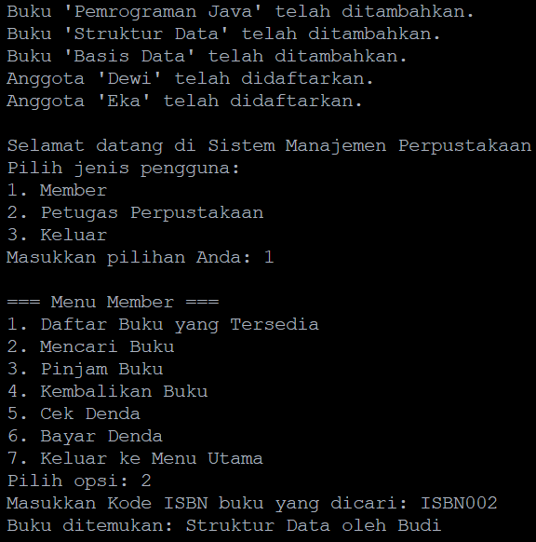

* Meminjam Buku

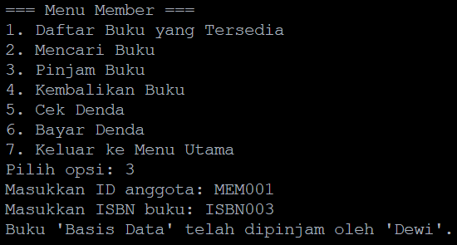

1. **Skenario Petugas**

* Menambah Buku

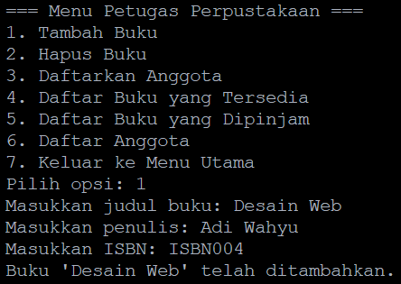

* Melihat Daftar Buku

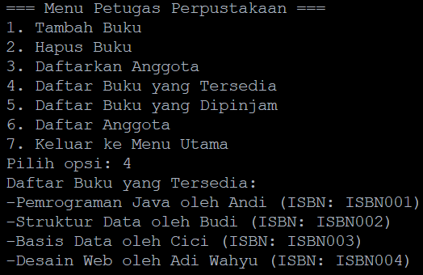

* Menambah Member

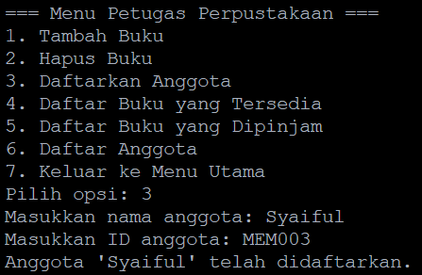

* Melihat Daftar Member

